Silver Classification & Labelling Harmonization (CLH) proposal – Q&A

- Which substances will be impacted by the silver CLH proposal submitted by Sweden on (DATE TO BE ADDED)?
Within the context of the Biocidal Products Regulation (BPR), Sweden has already submitted a similar proposal on silver nitrate and it is expected they will do the same on silver chloride. There will be an impact on silver and all silver compounds due to the current read-across approach followed in the REACH registration dossiers.
- Does EPMF support the silver CLH proposal made by Sweden?
EPMF does not support the CLH proposal made by Sweden. EPMF disagrees with the following classification proposals:
- TO BE ADDED when available
- Reprotoxic cat 1B
  - Fertility: EPMF believes that there is insufficient data on fertility effects of silver / silver substances for classification of the silver ion as Reprotoxic 1B, H360F. One published one-generation study on rodents provided limited evidence for effects on fertility following treatment with silver acetate. However, it is unclear whether the observed antifertility effect is due to effects on parent animals, and detailed investigations comparable to those in an Extended One Generation Reproductive Toxicity Study (EOGRTS) were not conducted. There were no clear effects on fertility observed in other studies with silver-containing active substances (SCAS) and nanosilver.
  - Development: EPMF believes current evidence on developmental effects of silver / silver substances is insufficient for classification of the silver ion as Reprotoxic 1B, H360D. Several studies are available on silver chloride, silver acetate, nanosilver, and silver-containing active substances (SCAS) with some suggesting pre- and/or post-natal effects on development of rodents. However, EPMF’s detailed assessment of the data shows that 1) there are several experimental design deficiencies in these studies and an EOGRTS would provide superior information and help us fill the current remaining data gaps; 2) some of the observed effects in the studies may not be directly attributed to the silver ion, and 3) some of the observed effects can be considered secondary / indirect effects.
  - In addition to the limited data available for classification as a reprotoxicant, it is questionable whether the existing studies can justifiably be extrapolated to elemental silver. EPMF is of the opinion that data for secure read-across is currently lacking and is in the process of generating further toxicokinetic data for read-across purposes.
The information and data used by EPMF are available in the related REACH registration dossiers as well as the interpretation of the data. A Testing Proposal for an EOGRTs has been submitted to fill in the data gap and allow an informed review of the classification.

- What is the process and timeline of a CLH proposal?
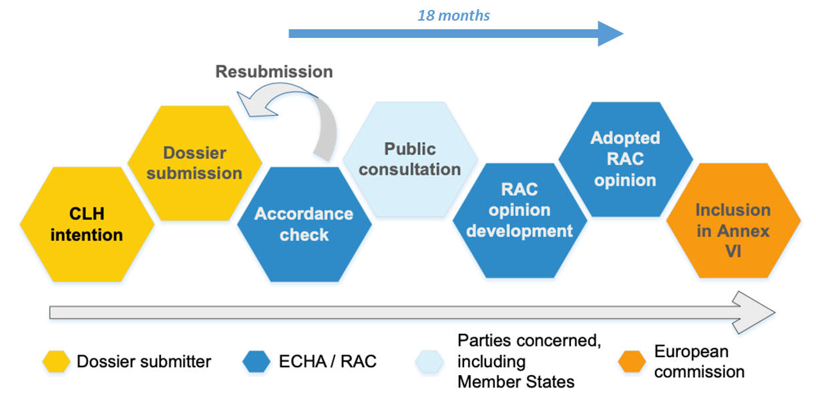
Figure from https://echa.europa.eu/regulations/clp/harmonised-classification-and-labelling
Based on the above process, a harmonized classification for silver could be published in the Annex VI of the CLP in 2022/2023 at the earliest.
- What would be the consequences of a classification as Reprotoxic cat 1B, H360F as proposed by Sweden?
The resultant regulatory and economic consequences would be considerable, not only for the precious metals industry, but also for the downstream industrial sectors using silver in critical technology applications such as photovoltaics, rapid charging, electronics, and medical devices. European Citizens will be directly impacted through jewellery, silverware, and bank investments. Indeed, a substance classified as Reprotoxic Cat. 1B can be restricted for consumer use as both a pure substance and as a component of a mixture (REACH, Articles 68.2 and 133.4). This means that silver would be banned from the EU market for certain electronics produced in the EU, brazing alloys (where silver is a key substitute for cadmium), silverware, jewellery, bank investments, and coinage for which silver has been used globally for thousands of years.
Equally important, there would be a detrimental impact in silver’s use in medical devices due to the constraints of the Regulation on Medical Devices [2012/0266/COD]. All the biocidal uses as active substance of silver and silver compounds would be restricted based on the Biocidal Products Regulation (528/2012). This in turn would affect a whole class of important silver-based micro-biocides used in medical and general disinfection applications. Such disinfectants are now recognised to be a key part of a highly effective response strategy to address the growing microbial antibiotic resistance and the related, worsening human health crisis.
Harmonizing the classification of silver as Reprotoxic Cat. 1B, based on flawed science and despite remaining data gaps, would mean that most of these critical applications of silver in the EU would be banned.
- Why would a proposal submitted in the context of the Biocidal Products Regulation (BPR) impact silver and silver compounds used in other applications?
The ongoing CLH process has broader consequences than the BPR. As soon as a substance has a harmonized classification, the impact is not limited to a particular regulatory context. It will affect the REACH registration process and will have to be applied by all silver producers and downstream users with important downstream regulatory consequences (e.g.; restriction for consumer uses).
- What role can EPMF play in the CLH process?
The CLH process allows the input of the stakeholders at two stages: the public consultation and the Risk Assessment Committee (RAC) discussion. EPMF is prepared to provide a strong scientific input to the public consultation and to contribute to the RAC discussions. EPMF will defend a responsible science-based process to define a harmonized classification for silver and silver substances. EPMF will continue to demand that gaps in the data be filled through rigorous studies such as the Extended One-Generation Reproductive Toxicity Study (EOGRTS; OECD TG 443), a testing proposal currently in the ECHA review process.
- What would be the impact of the CLH proposal on the EU silver market?
The EU silver market would be gravely impacted. Approximately 60% of silver in the EU market is owned by European Citizens in the form of jewellery, silverware, and financial investments based on a data gathering exercise conducted at EPMF.
It is important to highlight that Europe remains an important global player in silver as a commodity: Europe represents 37% of the silver recycling worldwide and 13% of the silver mine production worldwide.
EU competitiveness, Circular Economy targets and climate change commitments would be severely hampered. Indeed, silver, due to its unique properties for low contact resistance and high electrical and thermal conductivity, also plays a key role in Green Technologies (solar power, fast chargers, and in-road chargers).

- What is the impact of the CLH proposal on the ongoing Testing Proposal (EOGRTs) on silver and silver compounds under review by ECHA?
In the context of REACH, EPMF identified a scientific data gap related to the reproductive toxicity potential of silver and silver substances and addressed this in 2015 by submitting a testing proposal (TP) for an Extended One-Generation Reproductive Toxicity Study (EOGRTS; OECD TG 443) in the metallic silver REACH dossier. In April 2018, the TP was further updated to reflect the most recent scientific developments. The proposed test article in the TP is silver acetate, and outcome of this study is anticipated to be fully applicable to ionic silver irrespective of the donor silver substance forming this ion (i.e. to metallic silver and all silver compounds registered under REACH). On 18 December 2018, the Draft Decision (DD) on the EOGRTS has been issued with ECHA’s recommendation to accept the TP with the test design and test article as proposed by EPMF. The DD is currently undergoing the usual process for TP evaluation (see process below) and EPMF does not expect to receive the final decision before June 2019 at the earliest.
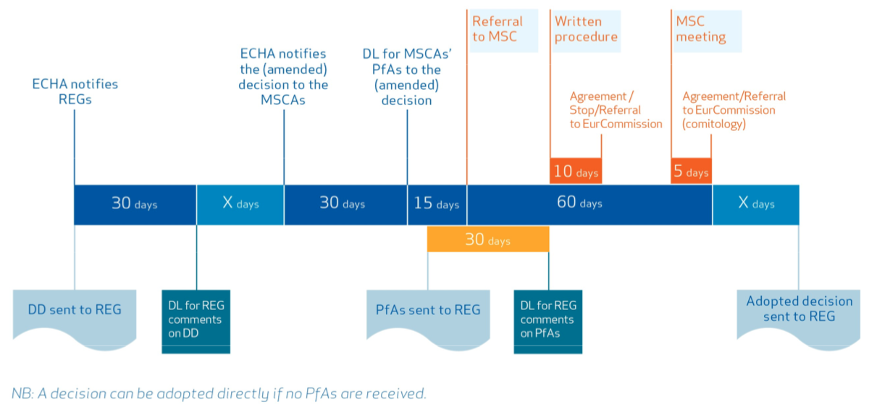
Figure from ECHA practical guide ‘How to act in dossier evaluation’, Jan 2019
The outcome of the EPMF proposed EOGRTS could have an impact on the classification of the Silver Containing Active Substances (SCAS) registered under the BPR and under review by Sweden (Kemi).
If the two processes are not aligned, a CLH proposal for silver could have a negative impact on the EPMF REACH dossiers and on the ongoing work to gather scientifically-sound data through the EOGRTS.

World silver survey 2018, Silver Institute, p. 43 (https://www.silverinstitute.org/wp-content/uploads/2018/04/2018WorldSilverSurvey.pdf)
World silver survey 2018 presentation, Silver Institute, April 2018, p. 17 (https://www.silverinstitute.org/wp-content/uploads/2018/04/WSS18Presentation.pdf)
See The Role of Silver in the Green Revolution, Silver Institute, July 2018 (https://www.silverinstitute.org/wp-content/uploads/2018/07/Role_of_Silver_Green_Revolution_28Jun2018.pdf)

